Silver Level Sponsor - $250
24” x 12” sign with your company’s name displayed near an entrance
Listing on Festival webpage and Festival Facebook event page
Two free all day ride bracelets and two beer vouchers
Beer Booth Sponsor - $500
24” x 6” sign with your company’s name displayed at the Beer Booth
Listing on Festival webpage and Festival Facebook event page
Listing in 2026 parish “Businesses to Patronize” brochure and welcome packet for new parishioners
Two free all day ride bracelets or meal vouchers, and two beer vouchers
Commercial announcements throughout the Festival
Diamond Level Sponsor - $2,500
8’ x 4’ name and logo sign displayed adjacent to the mainstage
Logo with link on Festival web page
One business spotlight post on Festival Facebook event page
Listing in 2026 parish “Businesses to Patronize” brochure and welcome packet for new parishioners
Two free all day ride bracelets, two meal vouchers, and two beer vouchers
Commercial announcements throughout the Festival
Gold Level Sponsor - $1,000
3’ x 2’ name and logo sign displayed at prominent road frontage or adjacent to the stage
Listing on Festival webpage and Festival Facebook event page
Listing in 2026 parish “Businesses to Patronize” brochure and welcome packet for new parishioners
Two free all day ride bracelets, two meal vouchers, and two beer vouchers
Commercial announcements throughout the Festival
Platinum Level Sponsor - $5,000
8’ x 4’ name and logo sign displayed adjacent to the mainstage
2 – 3’’ x 2’ name and logo signs displayed at the rides & food booths
Logo with link on Festival web page
Three business spotlight posts on Festival Facebook event page
Listing in 2026 parish “Businesses to Patronize” brochure and welcome packet for new parishioners
Four free all day ride bracelets, four meal vouchers, and four beer vouchers
Commercial announcements throughout the Festival
Presenting Sponsor - $10,000
Exclusive 3’ x 4’ name and logo sign at Festival entrances
Logo with link on Festival web page and over 100-yard signs installed throughout the community
8’ x 4’ name and logo sign displayed adjacent to the mainstage
4 – 3’’ x 2’ name and logo signs displayed at the entrances and rides & food booths
Five business spotlight posts on Festival Facebook event page
Listing in 2026 parish “Businesses to Patronize” brochure and welcome packet for new parishioners
Six free all day ride bracelets, six meal vouchers, and six beer vouchers
Commercial announcements throughout the Festival
2026 Christ the King Community Festival Sponsorship Form
Please make checks payable to Queen of Angels Church Academy. Federal Tax ID #74-2204264
*Vouchers can be picked up at the information booth when you arrive at the festival.

___ Presenting Sponsor ___Platinum Level Sponsor ___Diamond Level Sponsor
___Gold Level Sponsor ___Beer Booth Sponsor ___Silver Level Sponsor
Company: _________________________ Phone: ______________________________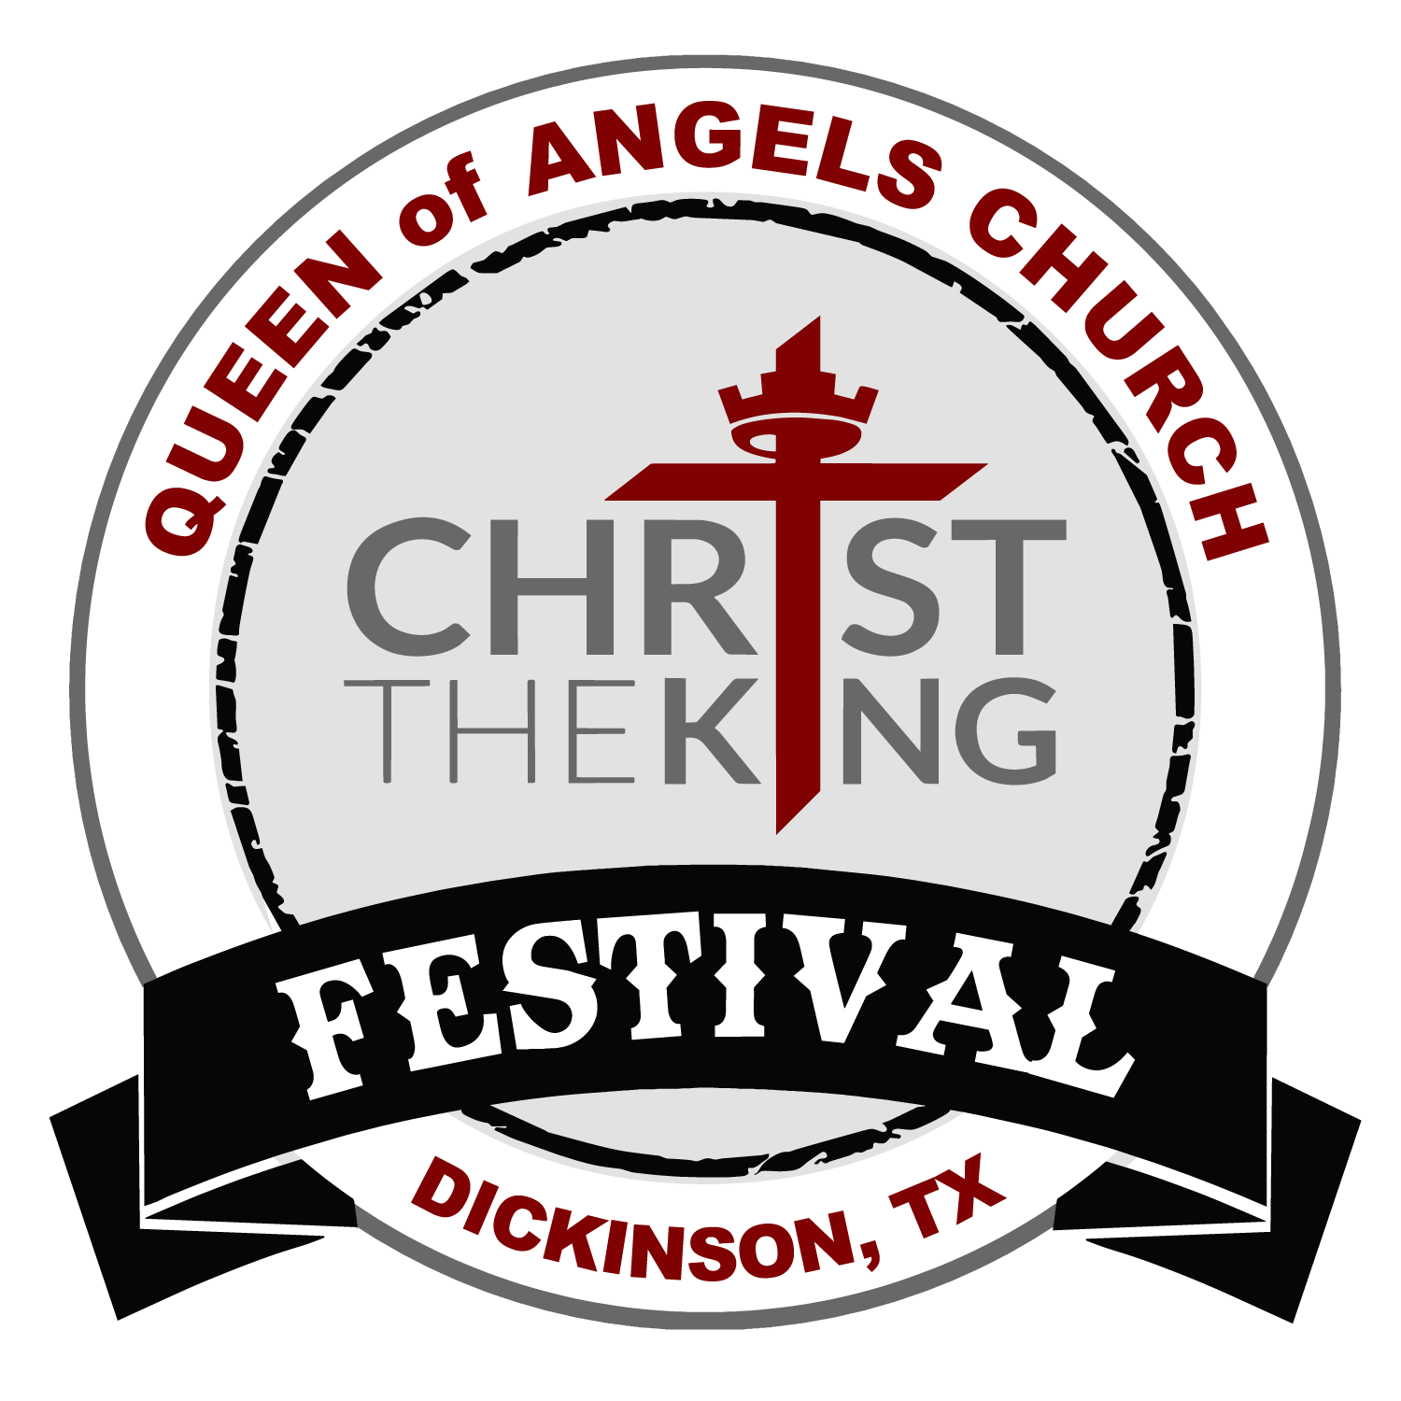
Address: _________________________ Email: ______________________________
Website: _________________________ Contact Name:_________________________
Type of Business: _______________________

